Body Check

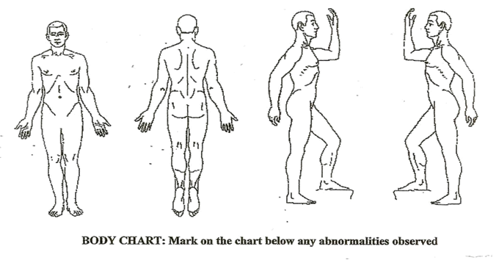Mark on the chart below any abnormities observed.

Participant name:____________________________________

Explain what happened:_______________________________________________________________________________________________________________________________________________________________________________________________________________________________________________________________________________________________________________________________________________________________________________________________________________________________________________________________________________________________________________________________________________________________________________________

Where/when:_____________________________________________________________________________________________________________________________________________________________________________________________________________

Why:___________________________________________________________________________________________________________________________________________________________________________________________________________________

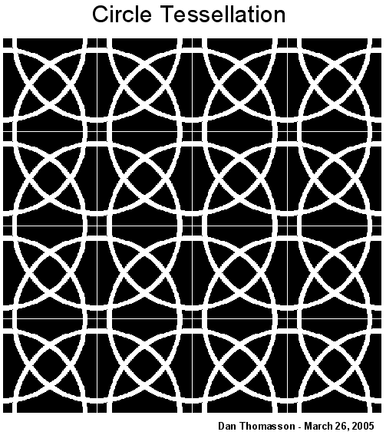What did you do? Describe First Aid administered and follow up: ________________________________________________________________________________________________________________________________________________________________________________________________________________________________________________________________________________________________________________________________________________________________________

Recommendations for follow up:_____________________________________________________________________________________________________________________________________________________________________________________________________________________

Staff completing report:

Name____________________________________

Signature_________________________________

Date____________________

Turn in completed form to Supervisor- original in Participant permanent book

Place copy in Internal Incident Book for review